MATCHPOINT TENNIS
1717 17M
Goshen, NY 10924
goshensportscomplex@yahoo.com
www.matchpointsports.com
Phone 845-294-0017 or 845-615-8560

WINER 2018…PIP SQUEAK TENNIS PRACTICE

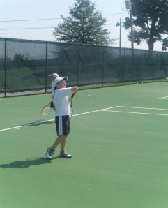
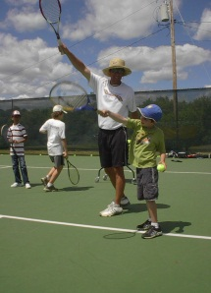
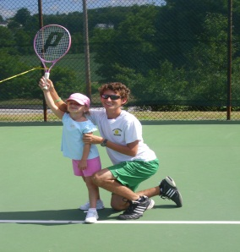
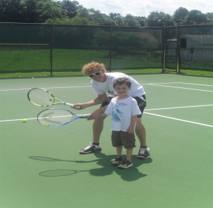

`

The MatchPoint Pip Squeak Practice is open to 3 to 6 year olds and geared towards the player with limited playing experience. This will be done with drills and games in a fun learning based environment.

SATURDAY 12:30 PM-1:15 PM
11/03/18 – 11/10/18 – 11/17/18 – 11/24/18 – 12/01/18 – 12/08/18 – 12/15/18 – 12/22/18

***************************************************************************************

NAME________________________________________________________________________________________

ADDRESS_____________________________________________________________________________________

PHONE_______________________________________________________________________________________

EMAIL_______________________________________________________________________________________

SATURDAY________________________________________

COST $175.00 MEMBER $200.00 NON MEMBER
Checks payable to Matchpoint

Check#________ Credit __________________________________________ EXP _________ CASH ______

If a class is missed, it can only be made up within the current 8 week clinic………..NO EXCEPTIONS

