MATCHPOINT TENNIS
1717 RT. 17M
Goshen, NY 10924
Phone 845-294-0017
goshensportscomplex@yahoo.com
www.matchpointsports.com

FALL 2018 ELITE PRO PRACTICE
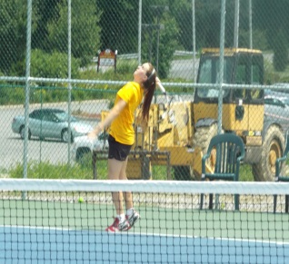
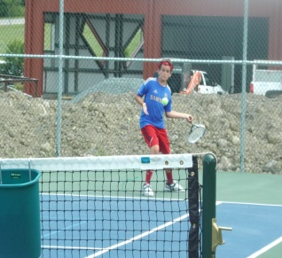
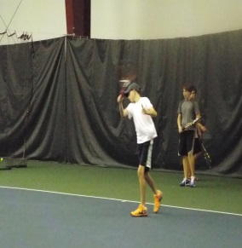

The MatchPoint Elite Pro Practice is geared towards preparing the top level Girls/Boys to the next level.
Elite Pro Players-highly competitive practice taught in both drill and play fashion.

Approval Required. Must attend minimum of two classes per week.

TUESDAY 4:30-6:00PM
9/04/18 – 9/11/18 – 9/18/18 – 9/25/18 – 10/02/18–10/09/18–10/16/18–10/23/18

THURSDAY 4:30 – 6:00PM
9/06/18– 9/13/18 – 9/20/18– 9/27/18–10/04/18–10/11/18–10/18/18–10/25/18

SUNDAY 10:30 – 12:00PM
9/09/18– 9/16/18– 9/23/18– 9/30/18– 10/07/18– 10/14/18– 10/21/18– 10/28/18
NAME_________________________________________________________________________________

ADDRESS______________________________________________________________________________

PHONE________________________________________________________________________________

EMAIL________________________________________________________________________________

TUESDAY ________________THURSDAY______________ SUNDAY __________________________

COST 2 CLASSES PER WEEK $465.00 MEMBER $525.00 NON MEMBER
CHECKS PAYABLE TO:………MATCHPOINT TENNIS

CHECK#__________ CREDIT CARD ____________________________ EXP. _________CASH________

If a class is missed, it can only be made up within the current 8 week clinic………..NO EXCEPTIONS

